Ventilation and Indoor Air Quality in Residential Bedrooms

Hagen Fritz Kerry Kinney, PhD David Schnyer, PhD

Student Member ASHRAE

Atila Novoselac, PhD Zolta Nagy, PhD

Associate Member ASHRAE Associate Member ASHRAE

Abstract

From submitted abstract: Few studies have investigated human exposure to indoor air pollutants during sleep. Given that we spend about a third of our days sleeping, it constitutes a significant exposure period with limited active control over the environment. In this study, we use consumer-grade sensors to measure key indoor air pollutants and use carbon dioxide to estimate ventilation rates so that we can better understand the human sleep microenvironment. We developed a sensing platform capable of measuring light levels, temperature, relative humidity, carbon dioxide, particulate matter (PM2.5 and PM10), total volatile organic compounds, carbon monoxide, and nitrogen dioxide. The device was distributed to 30 university students living in Texas from early June to early September 2020. Data were collected continuously at 1-minute intervals in their bedroom environments. Participants were also provided a wristband to be worn at all times. The wristband was used to determine when participants were asleep which allowed us to limit the data analysis to truly sleeping times and exposure. A survey administered at the beginning of the study period provided insight into the home environment including questions regarding roommates, pets, cooking habits, air filter use, etc. which provides context to the collected data.

introduction

Sleep is important

Methodology

This research project was a subset of a larger study aimed at understanding student’s behaviors and environmental exposures throughout the course of their day using numerous affordable and mobile sensing technologies. However, the scope of the project is limited to devices, variables, and participants that were studied in order to help address environmental exposure in those participants’ bedrooms.

Student participants were recruited from the University of Texas at Austin (UT) and underwent an initial screening before being consented into the study. Students were consented into the study over a period of two weeks with full enrollment completed by May 1st, 2020. A total of 71 participants were enrolled in the study, however only 30 participants received environmental monitors. The study concluded when participants scheduled a virtual meeting with one of the study coordinators in early September 2020 for an exit interview and to coordinate shipping study materials back to the university.

Environmental Quality Monitoring

To get an initial impression of the environment participants lived in, a one-time survey was administered asking various questions regarding pollutant exposures at home (smoking/vaping, pets, floor type, etc.) and cleaning habits (portable air cleaner use, disinfecting practices, etc.). To monitor the indoor environmental quality (IEQ) of the participants’ bedrooms during the study period, we developed, calibrated, and deployed our own monitoring device called the Building EnVironment and Occupancy (BEVO) Beacon. The BEVO Beacon, pictured in Figure 1, includes a Raspberry Pi 3B+ (RPi) wired to six affordable, commercially available sensors; one 1”x1” cooling fan; and a batteried-powered clock to keep time when the device is not connected to WiFi. Within the BEVO Beacon, the RPi is housed in a separate chamber from the sensors where the fan provides air blown to help cool the RPi processor. All six sensors are either exposed directly to the air or have inlets that pull from outside the wooden housing. The sensos on the BEVO Beacon measure temperature, relative humidity (RH), light levels, carbon dioxide (CO2), particulate matter with aerodynamic diameters of 2.5 (PM2.5) and 10 (PM10) micrometers, total volatile organic compounds (TVOCs), nitrogen dioxide (NO2), and carbon monoxide (CO). Each sensor attempts to take 5 readings over a period of 10 seconds, logs the average of these readings, and then sleeps for 50 seconds providing data at one-minute resolution. Data are stored locally on the RPi and can be accessed remotely if the BEVO Beacon is connected to WiFi.

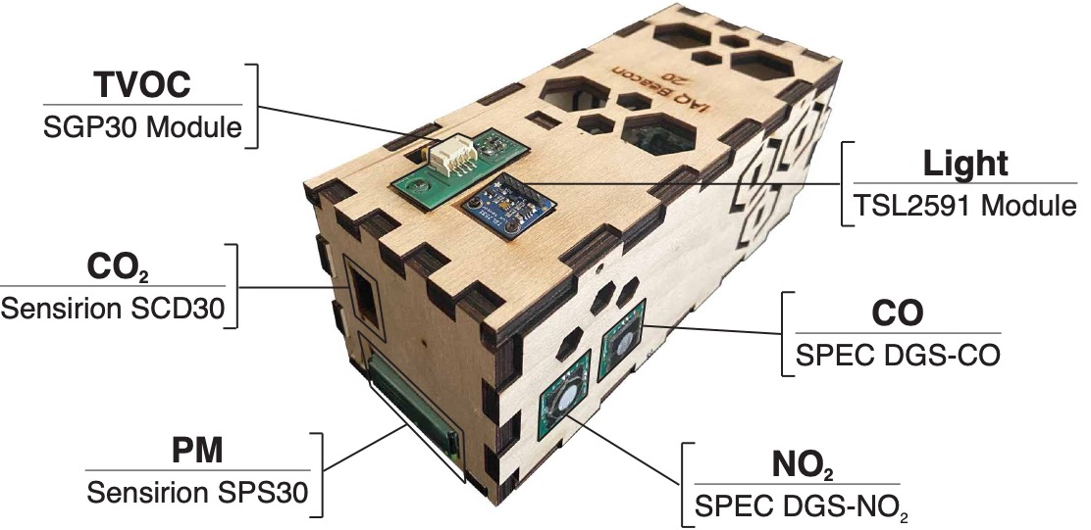

Figure 1. The BEVO Beacon and the 6 sensors, the primary variable they measure, and the sensor name.

Mobile Sensing

As part of the study, all participants were asked to download and use the Beiwe smartphone application. The Beiwe Research Platform [] provides digital phenotyping in the form of data collected from smartphone sensors and responses from Ecological Momentary Assessments (EMAs) that researchers can schedule and send via the app. At the initial consenting interview, students were given a login so that data were pushed to a secure server accessible by the reserachers to monitor participation and data collection.

Fitbit Inspire HR devices were distributed to the same 30 participants who received the BEVO Beacon and their accounts were linked to a Fitabase server to securely store and monitor data. This particular brand of Fitbit houses a heart rate monitor and accelerometer to more accurately track activity and sleep.

Pre-Processing IEQ Data

BEVO Beacons were administered after the initial consenting period starting June 1st, restricting the study period between June 2020 and September 2020. The BEVO Beacon, once powered on, continuously monitors the environment, but we wanted to make sure to only included data during periods when participants were home and in their bedrooms. Fitbit logs the start and stop time for any sleep event that the device detects lasting at least 3 hours. Therefore, the IEQ data from the BEVO Beacon was restricted to only periods when the Fitbit was logging sleep data. However, we cannot guarantee that participants are sleeping in the same environment that the BEVO Beacon is monitoring unless we cross reference the addresses participants provided with the GPS monitoring provided by the Beiwe app. By comparing the longitude and latitude values measured by Beiwe to those corresponding to the participants’ addresses, the IEQ data was futher filtered so as to only include nights when the participants were home and asleep.

Ventilation Estimates

Results

Summary of Data Collected